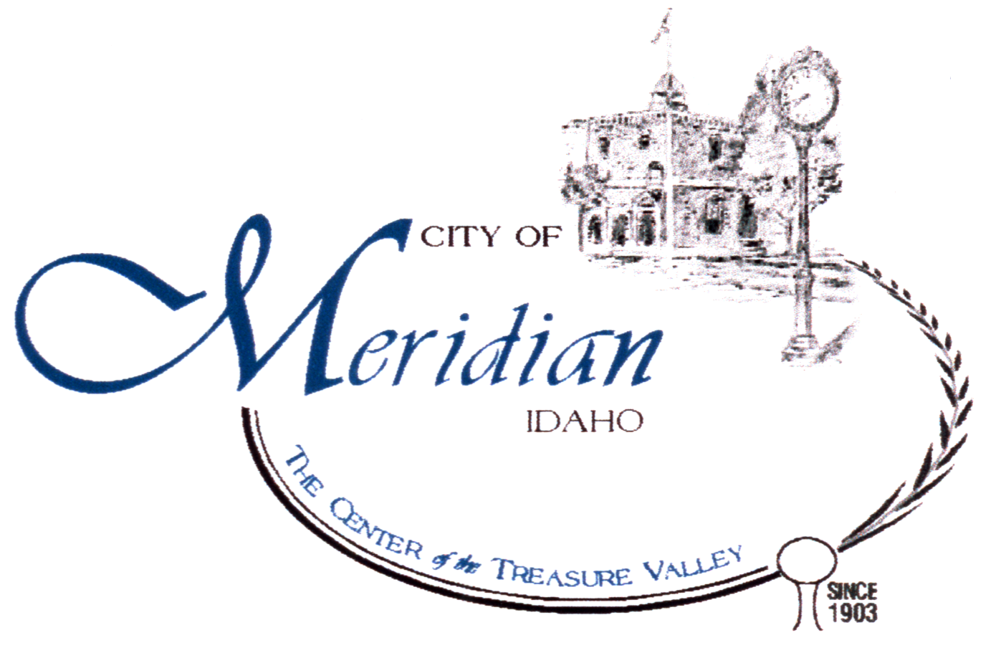

Meridian Water Dept.
2235 N.W. 8TH STREET
MERIDIAN, ID 83646
(208) 888-5242
(208) 884-1159 FAX
www.meridiancity.org

PWS # 4010097
Annual Water Quality Report
2006

We want to inform you about the quality of the water and the services that we deliver to you every day. We are committed to providing a safe and dependable supply of drinking water to approximately 24,000 connections serving about 71,866 customers. Our water is pumped from deep in the Boise Aquifer. We currently operate nineteen supply wells located throughout the City.

We would like to extend a welcome to those who have recently moved to our city. Meridian is one of the greatest places in the world to live. Like most regions Meridian water may have a different mineral content and the water here may taste different than what you have grown accustom to drinking. I assure you that Meridian water is of a high quality and is well maintained.

This annual report reflects the quality of our water from the previous year. The Meridian Water Department routinely monitors for contaminants in your drinking water to meet federal and state standards. Testing frequencies range from monthly to once every nine years, depending on the contaminant.

The following definitions may help you better understand the terms and abbreviations in the table on the following pages.

Maximum Residual Disinfectant Levels (MRDL) - The highest level of disinfectant allowed in drinking water. There is convincing evidence that addition of a disinfectant is necessary for control of microbial contaminants.
Maximum Residual Disinfectant Level Goal (MRDLG) - The level of drinking water disinfectant below which there is no known or expected risk to health. MRDLGs do not reflect the benefits of the use of disinfectants to control microbial contamination.
Maximum Contaminant Level Goal - The “Goal” (MCLG) is the level of a contaminant in drinking water below which there is no known or expected risk to health. MCLGs allow for a margin of safety.
Maximum Contaminant Level - The “Maximum Allowed” (MCL) is the highest level of a contaminant allowed in drinking water. MCLs are set as close to the MCLGs as feasible using the best available treatment technology.
Action Level- The concentration of a contaminant, which, if exceeded, triggers treatment, or other requirements which a water system must follow.

We are proud of this table, which shows that your drinking water meets or exceeds all Federal and State requirements. We have learned through our monitoring and testing that some contaminants are present. However, your water IS SAFE at the levels detected. Remember that the mere presence of a contaminant does not necessarily indicate that the water poses a health risk. More information about contaminants and their potential health effects may be obtained by calling the Environmental Protection Agency’s Safe Drinking Water Hotline at 1-800-426-4791 or http://www.epa.gov/safewater/hotline/.

If you are not on Meridian's City Water System, the amount of contaminants in your water will differ from those listed on the preceding pages. If you have a private well, you should consider testing your water for certain contaminants, especially bacterial contaminants, on a regular basis.

In order to ensure that tap water is safe to drink, EPA prescribes regulations which limit the amount of certain contaminants in water provided by public water systems. Food and Drug Administration (FDA) regulations establish limits for contaminants in bottled water which must provide the same protection for public health.

Some people may be more vulnerable to contaminants in drinking water than the general population. Immuno-compromised persons such as persons with cancer undergoing chemotherapy, persons who have undergone organ transplants, people with HIV/AIDS or other immune system disorders, some elderly, and infants can be particularly at risk from infections. These people should seek advice about drinking water from their health care providers. EPA/CDC guidelines on appropriate means to lessen the risk of infection by cryptosporidium and other microbiological contaminants are available from the Safe Drinking Water Hotline at 1-800-426-4791 or http://www.epa.gov/safewater/hotline/.

Contaminants that may be present in source water before we treat it include:
- Microbial contaminants, such as viruses and bacteria, which may come from sewage treatment plants, septic systems, agricultural livestock operations, and wildlife.
- Inorganic Contaminants, such as salt and metals, which can be naturally-occurring or result from urban storm water runoff, industrial, or domestic water discharges, oil and gas production, mining, or farming.
- Pesticides and herbicides, which may come from a variety of sources such as agriculture, urban storm water runoff, and residential uses.
- Organic chemical contaminants, including synthetic and volatile organic chemicals, which are by-products of industrial processes and petroleum production, and can also come from gas stations, urban storm water runoff, and septic systems.
- Radioactive contaminants, which can be naturally-occurring or be the result of oil and
gas production and mining activities.

Drinking water, including bottled water, may reasonably be expected to contain at least small amounts of some contaminants. The presence of contaminants does not necessarily indicate that water poses a health risk. More information about contaminants and potential health effects can be obtained by calling the Environmental Protection Agency’s Safe Drinking Water Hotline at 1-800-426-4791 or http://www.epa.gov/safewater/hotline.

Please help us to protect and conserve this vital resource. A dependable supply of clean, high-quality water is essential to our community, our way of life, and our children’s future. We want to keep you informed about your water utility. If you have questions about this report or concerns about your water utility, please contact Rick Clinton at (208) 888-5242 or visit our website at www/meridiancity.org. The City of Meridian City Council generally has regularly scheduled meetings every Tuesday.

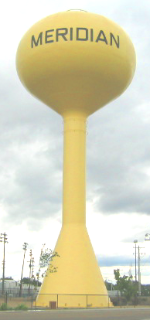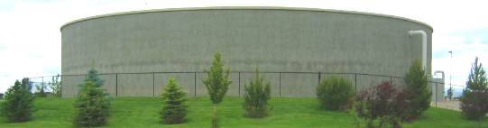

What we are doing to maintain and improve the quality of water in Meridian:

- We are proud to be one of the first systems in Idaho to use poly vinyl chloride (PVC) well casings. PVC casing significantly reduces water quality concerns associated with the corrosion of steel casing.
- We have one of the best cross connection control programs in Idaho. The risk of contamination from sources outside our water system is reduced as we implement cross connection control.
- We chlorinate the water, which kills harmful organisms and reduces the undesirable taste and odor sometimes caused by natural occurring minerals.
- Water mains are flushed annually. Flushing clears out the buildup of naturally-occurring sediments within the system that can cause discoloration and taste and odor problems.
- We are taking steps to reduce discoloration in the water. In addition to the annual spring flush we have added a fall and winter flush using newly installed discharge lines. The new installs can clear the lines without putting water on the roads. We have also reevaluated the chlorine settings to reduce oxidation that causes discolored water.
- Multiple aquifers sampling from test wells enables us to target the aquifer that provides the finest quality of water when we construct new wells.
- We have implemented security improvements to insure that your water remains safe.
- We collected over 1000 water samples for lab analysis of various contaminants in 2006.

Notice: Of the 1000 Plus samples taken during the 2006 monitoring period, Meridian Water failed to monitor for atrazine at well 11 near the 2300 block of E. Lanark Street. This resulted in a failure to monitor violation. Even though it was not an emergency, as our customers, you have a right to know what happened.
To correct this violation, well 11 was tested for atrazine early in 2007, restoring the Meridian Water System to full compliance. No other corrective actions or need to use an alternative water supply was necessary.
Results of the atrazine test in early 2007 indicate well 11 continues to be well under the maximum contamination level (MCL) for atrazine and is an excellent source of clear potable water. Some people who drink water containing atrazine well in excess of the MCL over many years could experience problems with their cardiovascular system or reproductive difficulties.

Please share this information with all the other people who drink this water, especially those who may not have received this notice directly (for example, people in apartments, nursing homes, schools and businesses). You can do this by posting this notice in a public place or distributing copies by hand or mail.

Meridian Water Department Conservation Tips

- Water your lawn early in the morning or at night to avoid excess evaporation. Do not over-water your lawn.
- Fully load the dishwasher and clothes washer before running.
- Defrost frozen food in the refrigerator or in the microwave instead of running hot water over the food.
- When washing dishes by hand, do not let the water run.
- Use a broom, rather than a hose, to clean sidewalks and driveways.
- If you have a swimming pool, use a cover. You will cut the loss of water due to evaporation by 90 percent.
- Repair dripping faucets and leaky toilets. Dripping faucets can waste up to 2,000 gallons of water each year in the average home. Leaky toilets can waste as much as 200 gallons per day.
- Do not leave the sink running while you brush your teeth.

Drinking water is one of our most important and valuable natural resources. We urge you to conserve water, and also your money, by using it wisely.

Source: AWWA

